Capstone project: Life Expectancy and GDP

Visualize data from the World Health Organization

# Introduction

This is a codecademy Capstone project in which i analyzed data on GDP and life expectancy from the World Health Organization and the World Bank to try and identify the relationship between the GDP and life expectancy of six countries:

* China
* USA
* Germany
* Zimbabwe
* Chile
* Mexico

# Violin Plots To Compare Life Expectancy Distributions

The following violin plot depicts the average life expectancy by country between 2000 and 2015. Violin plots are a useful tool to depict the spread of data around both mean (average) and median (middle value) and can therefore provide a good overview over data.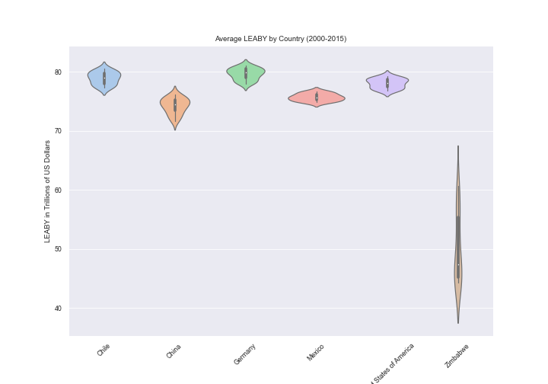

# The facet grid of scatter graphs mapping GDP as a function Life Expectancy by country

The following scatter plots show how GDP and life expectancy have developed over time for each country. Whereas some countries have seen developments in their life expectancy (e.g. Zimbabwe), others have seen larger increases in GDP (China, USA). In comparison to China, the USA and Zimbabwe, the other countries’ life expectancy and GDP, on the other hand, have both not changed very much.

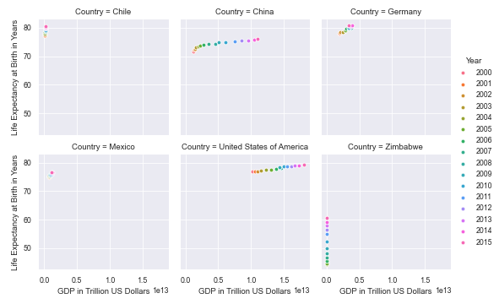

# The facet grid of line graphs mapping Life Expectancy and GDP by country

Previous scatter plot can be little tricky in readability and are not perfectly suited for analyzing developments over time. The following two line graphs are more useful for analyzing the development of GDP and life expectancy over time

Interestingly, a GDP of China suddenly

was growing quickly as it can, and nowadays China emergence as a leading world economy. According to <https://oecdobserver.org/>, this extraordinary economic performance has been driven by changes in government economic policy. The transformation started in the agricultural sector more than two decades ago and was extended gradually to industry and large parts of the service sector, so that price regulation was essentially dismantled by 2000 outside the energy sector. During this period, the government introduced a pioneering company law that for the first time permitted private individuals to own limited liability corporations

### *GDP by country over time*

### *Life expectancy by country over time*

